AgriGuardian AI: An SOA-Based Agentic Framework for Carbon-Aware Autonomous Irrigation in Paddy Cultivation

Abstract:-
Modern agriculture requires decisions that combine soil characteristics, weather conditions, crop suitability, yield expectations, nutrient requirements, pest and disease risks, and market conditions. These decisions are often handled through separate tools, making it difficult for farmers to obtain a single, context-aware recommendation. AgriGuardian AI is proposed as an SOA-based agentic smart crop advisory and decision support system that integrates crop recommendation, yield prediction, fertilizer advisory, pest-risk estimation, market-driven profit analysis, image-based crop disease detection, treatment recommendation, and real-time weather and market information. The project is grounded in the integrated smart crop advisory framework reported by Shajil Kumar P. A., Sumit Shinde, and Ayush Mithbavkar [1]. The proposed implementation decomposes the advisory functions into independently deployable microservices and exposes them through REST APIs using Spring Boot, Eureka Service Discovery, and Spring Cloud Gateway. JWT authentication, role-based authorization, CORS, database-per-service, API testing, unit/integration testing, and continuous integration are incorporated to satisfy the Service-Oriented Architecture requirements of the project. An AI decision agent coordinates outputs from the individual analytical services and converts them into a unified, explainable agricultural recommendation. The system is designed as decision support rather than a replacement for agricultural experts, and final evaluation will report measured model and system metrics after implementation.

1. Introduction:-
Agricultural decision making is increasingly data intensive. A farmer may need to decide which crop is appropriate for a field, how much yield can reasonably be expected, what nutrients are required, whether a disease is present, what the near-term pest risk is, and whether market conditions support cultivation or sale. Research on integrated smart advisory systems shows that combining machine learning, deep learning, rule-based reasoning, and real-time external data can provide a more holistic decision-support workflow [1].
The selected base paper presents an integrated AI-based smart crop advisory system with seven interconnected components: crop recommendation, yield prediction, fertilizer advisory, pest-risk estimation, market-driven profit prediction, image-based crop disease detection, and treatment recommendation. It also incorporates real-time weather and agricultural market information through APIs. The paper reports Random Forest for crop recommendation, regression-based models for yield prediction, EfficientNet-based deep learning for disease classification, and rule-based inference for fertilizer and treatment advisories [1].
AgriGuardian AI adopts this functional scope as its baseline and focuses on an additional architectural contribution: decomposition of agricultural capabilities into SOA-based services and orchestration of their outputs through an agentic decision layer. Recent research also discusses generative AI as an interface between farmers and complex agricultural algorithms, particularly for translating technical outputs into understandable guidance [2].

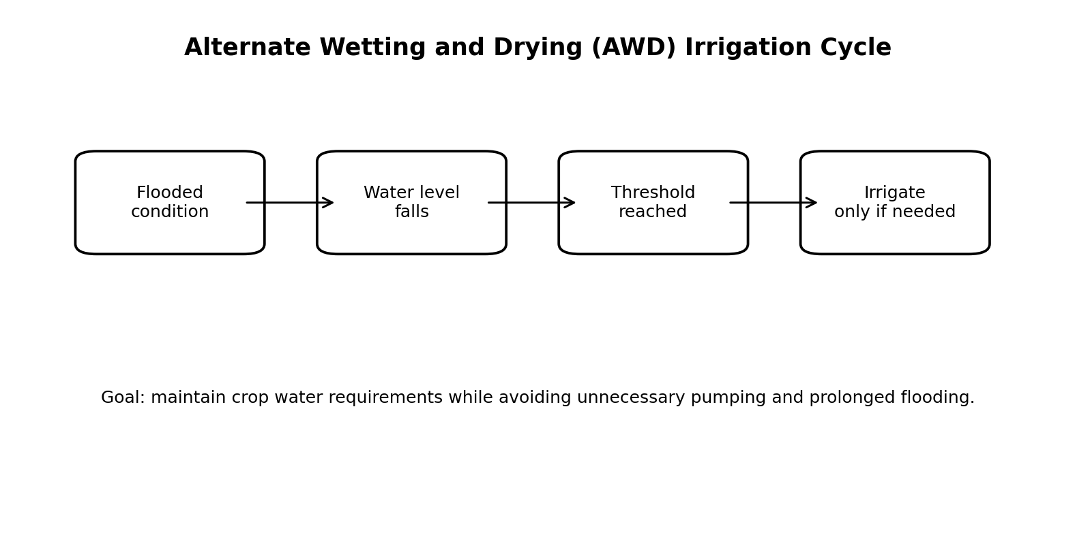

1.1 Problem Statement
Agricultural advisory capabilities are frequently fragmented across separate prediction, diagnosis, weather, and market tools. The project addresses the need for a unified decision-support workflow in which these capabilities operate as interoperable services and their outputs can be coordinated into a context-aware recommendation.

1.2 Objectives
- Implement the agricultural baseline capabilities described in the selected base paper.
- Provide crop recommendation using soil and environmental attributes.
- Provide yield prediction using relevant crop, soil, and environmental variables.
- Generate fertilizer and treatment advisories using structured rules and domain knowledge.
- Estimate pest risk from crop and environmental information.
- Detect selected crop diseases from images using a deep-learning model.
- Provide market-driven profit information using agricultural market data.
- Integrate real-time weather and market information through APIs.
- Expose capabilities through SOA-based microservices and REST APIs.
- Coordinate service outputs using an AI decision agent and present an explainable final advisory.
- Provide secure, testable, continuously integrated software using JWT, role-based access, Postman, automated tests, and GitHub Actions.

1.3 Contributions
- An integrated implementation of the seven agricultural advisory capabilities defined by the base paper.
- An SOA decomposition in which agricultural capabilities are independently deployable and accessible through RESTful service contracts.
- An agentic orchestration layer that combines service outputs into a unified agricultural decision.
- An explainable presentation layer that exposes the major factors supporting a recommendation.
- An engineering workflow incorporating authentication, service discovery, API gateway routing, database isolation, automated testing, and CI/CD.

2. Related Work and Research Foundation:-
The primary research foundation is the 2026 paper by Shajil Kumar P. A., Sumit Shinde, and Ayush Mithbavkar, which proposes an integrated AI-based smart crop advisory system for holistic agricultural decision making in Maharashtra [1]. Its seven-component design combines machine learning, deep learning, rule-based reasoning, real-time weather information, and agricultural market data.
Recent work on interpretable crop and fertilizer recommendation demonstrates the use of soil nutrients, temperature, humidity, and climate variables in data-driven recommendations [3]. Reviews of deep-learning approaches for disease detection and fertilizer recommendation identify computer vision, multimodal learning, and IoT-enabled agriculture as important smart-farming directions [4].
Zhang and Yadav discuss generative AI as a human-centered interface between farmers and complex agricultural algorithms [2]. Their work motivates the conversational and explanation layer of AgriGuardian AI, while the underlying agricultural predictions remain traceable to the dedicated analytical services.

2.1 Baseline-to-Proposed Mapping

Base-paper capability | AgriGuardian service | Implementation role
Crop recommendation | Crop Recommendation Service | ML prediction
Yield prediction | Yield Prediction Service | Regression prediction
Fertilizer advisory | Fertilizer Service | Rule-based advisory
Pest-risk estimation | Pest Risk Service | Risk classification
Market-driven profit prediction | Market/Profit Service | Prediction + market data
Disease detection | Disease Service | Image classification
Treatment recommendation | Treatment Service | Rule/knowledge-based advice
Weather information | Weather Service | External API
Unified recommendation | Agent Service | Cross-service orchestration
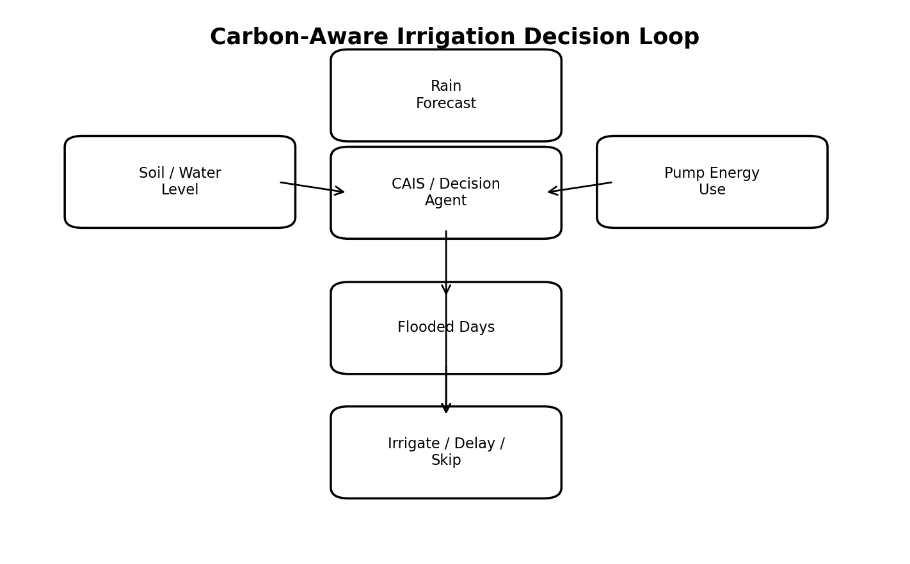

3. Proposed System:-
AgriGuardian AI is organized as a layered decision-support platform. The presentation layer provides a farmer-facing web interface. The gateway layer routes requests to authenticated services. The service layer contains the agricultural analytical modules. The data and integration layer manages service-specific databases and external APIs. Finally, an agentic orchestration layer consumes validated service outputs and produces a unified recommendation.

3.1 Functional Modules
Crop Recommendation: Accepts soil and environmental inputs and returns the recommended crop using the implemented baseline ML model.
Yield Prediction: Estimates expected production from crop, soil, and environmental variables.
Fertilizer Advisory: Maps crop and soil conditions to a structured fertilizer recommendation using rule-based knowledge.
Pest-Risk Estimation: Estimates pest risk from crop and relevant environmental conditions.
Market/Profit Prediction: Combines crop, expected yield, and market information to estimate economic opportunity.
Disease Detection: Accepts a crop/leaf image and predicts the disease class using the selected deep-learning model.
Treatment Recommendation: Maps the detected disease to a structured treatment/advisory response.
Weather Service: Retrieves weather and forecast information through an external API.
AI Decision Agent: Coordinates outputs from the analytical services and generates a unified, explainable advisory.

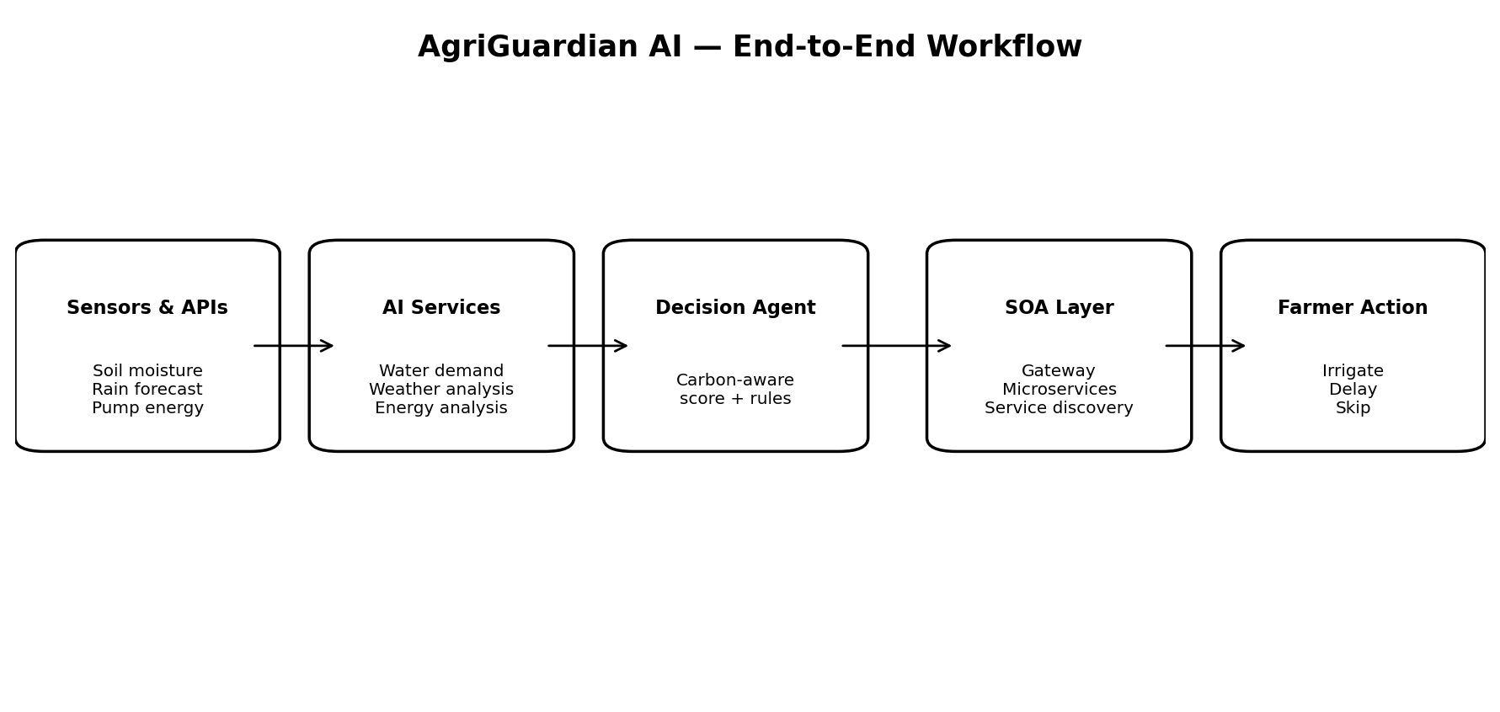

4. System Architecture and SOA Design:-
The project follows Service-Oriented Architecture by treating each major agricultural capability as a service with a defined contract. Services communicate using REST APIs and are independently deployable. Eureka provides service discovery, while Spring Cloud Gateway provides a single entry point for client requests. Each service owns its data to reduce coupling and support independent evolution.
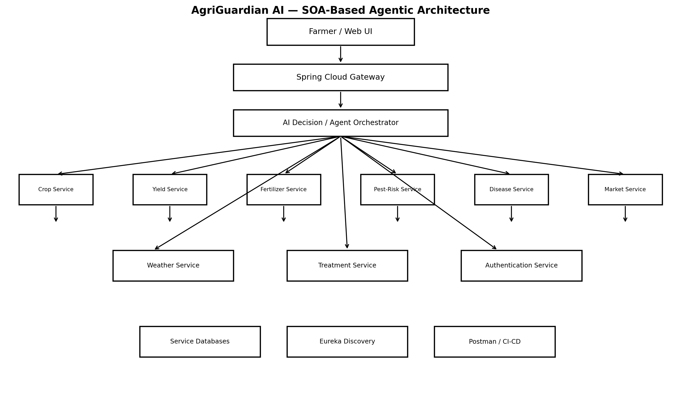

4.1 Service Contracts

Service | Example Endpoint | Purpose
Authentication | POST /api/auth/login | Login and JWT token issuance
Crop | POST /api/crop/recommend | Crop recommendation
Yield | POST /api/yield/predict | Yield estimation
Fertilizer | POST /api/fertilizer/recommend | Fertilizer advisory
Pest | POST /api/pest/risk | Pest-risk estimation
Disease | POST /api/disease/detect | Image-based disease prediction
Treatment | POST /api/treatment/recommend | Treatment/advisory generation
Weather | GET /api/weather/current | Weather information
Market | POST /api/market/profit | Market/profit prediction
Agent | POST /api/agent/advice | Unified agricultural decision

4.2 Security and Reliability
- JWT-based authentication for protected API access.
- Role-based authorization for farmer/admin functions.
- CORS configuration for controlled frontend-backend interaction.
- Input validation at API boundaries.
- Centralized routing through the gateway.
- Independent service failure isolation and logging.
- Unit and integration tests for core service behavior.

5. Methodology:-
The methodology is derived from the functional and algorithmic structure of the selected base paper, while the software engineering workflow is adapted to the SOA requirements of the project.
Data Acquisition. Prepare datasets for crop recommendation, yield prediction, disease images, market information, and environmental variables. Obtain live weather data through an API.
Preprocessing. Validate schemas, handle missing values where applicable, encode categorical variables, scale features where required, and resize/normalize images for disease classification.
Model Development. Train the crop recommendation, yield prediction, disease classification, and market/profit models. Implement fertilizer and treatment knowledge as explicit rules.
Model Evaluation. Use accuracy, precision, recall and F1-score for classification; MAE, RMSE and R² for regression; and response latency for API services.
Serviceization. Wrap each analytical capability as a REST-enabled microservice or model-serving endpoint.
Integration. Register services with Eureka and expose them through Spring Cloud Gateway.
Agentic Orchestration. Validate and combine outputs from multiple services and create a final recommendation with supporting factors.
User Presentation. Display predictions, confidence/metrics where available, advisory text, and explanations through the React frontend.
Testing and CI/CD. Validate APIs with Postman, execute unit/integration tests, run security checks, and automate builds through GitHub Actions.

5.1 Agentic Decision Workflow
The agentic component does not replace the underlying predictive models. It acts as an orchestration and interpretation layer. A typical sequence is: collect farmer and field inputs; invoke relevant analytical services; validate returned values; identify interactions such as weather and market conditions; combine evidence using explicit decision rules and model outputs; and generate a final recommendation with a concise explanation. This is consistent with the broader research direction of using generative AI as an accessible interface to agricultural algorithms [2].

6. Implementation Plan:-
Implementation is divided into independent layers so that baseline agricultural functionality can be validated before full SOA integration.
- Phase 1: Crop recommendation baseline.
- Phase 2: Disease detection and treatment advisory.
- Phase 3: Yield, fertilizer, pest-risk, and market/profit modules.
- Phase 4: Weather and market API integration.
- Phase 5: REST microservices.
- Phase 6: Eureka, API Gateway, JWT, CORS, and database-per-service.
- Phase 7: AI decision agent and explanation layer.
- Phase 8: React frontend, Postman collections, tests, GitHub Actions, and documentation.

6.1 Technology Stack
Layer | Technology
Frontend | React, HTML/CSS, Tailwind CSS
Backend | Java, Spring Boot, Spring Cloud
Service Discovery | Eureka Server
API Gateway | Spring Cloud Gateway
Security | JWT, role-based authorization, CORS
AI/ML | Python, scikit-learn, TensorFlow/PyTorch as appropriate
Database | PostgreSQL; database-per-service
API Testing | Postman
Testing | JUnit, integration tests
DevOps | GitHub, GitHub Actions, Docker
Project Management | Jira
Architecture | Lucidchart AI

7. Novelty and Research Contribution:-
The agricultural capabilities are grounded in the selected base paper. Therefore, novelty is not claimed merely from repeating those capabilities. The proposed work differentiates itself primarily through the software architecture and coordination mechanism used to transform multiple predictions into one actionable workflow.

7.1 Novelty 1 — Agentic Decision Orchestration
Independent crop, disease, yield, fertilizer, pest, market, and weather outputs are coordinated by an AI decision agent. The agent identifies relevant outputs for the current request and presents a unified recommendation while retaining traceability to the underlying service results.

7.2 Novelty 2 — SOA-Based Agricultural Intelligence
Each major capability is implemented as an independently deployable service. This enables independent model updates, service-level testing, API reuse, and fault isolation.

7.3 Novelty 3 — Explainable Unified Advisory
The final interface presents the principal factors supporting a recommendation. Rather than returning only a predicted class or numeric value, it presents supporting evidence such as soil suitability, weather context, disease status, expected yield, and market information.

8. Societal Impact and SDG Alignment:-
The project aligns primarily with SDG 2, particularly Target 2.4, which calls for sustainable food production systems and resilient agricultural practices that increase productivity while maintaining ecosystems and improving adaptation to climate-related conditions [5]. It also relates to SDG 13 through weather-aware and risk-aware decision support that can help users account for climate-related variability [6].
- Supports data-informed crop and input decisions.
- Provides early disease and pest-risk information.
- Combines production and market information for decision support.
- Reduces fragmentation by presenting multiple agricultural services through one interface.
- Provides a modular platform that can be extended with local datasets, languages, and additional services.

9. Evaluation Framework:-
This draft does not fabricate experimental scores. Final values must be filled using the actual trained models, test datasets, and running services.
Component | Metric | Observed result
Crop recommendation | Accuracy, Precision, Recall, F1 | To be measured
Yield prediction | MAE, RMSE, R² | To be measured
Disease detection | Accuracy, Precision, Recall, F1 | To be measured
Pest-risk | Accuracy/F1 or appropriate metric | To be measured
Market/profit | MAE/RMSE/R² where applicable | To be measured
API services | Latency, success rate | To be measured
System integration | End-to-end response time | To be measured

9.1 Demonstration Workflow
- Authenticate as a farmer user.
- Enter field/soil/environmental parameters and request crop advice.
- Display recommended crop and model output.
- Upload a crop/leaf image and display disease prediction and treatment advisory.
- Display weather information and risk context.
- Display yield and fertilizer recommendations.
- Display market/profit information.
- Invoke the decision agent for a unified recommendation.
- Open Eureka, Gateway, and Postman views to demonstrate SOA integration.
- Show GitHub history, tests, and CI/CD evidence for individual implementation.

10. Limitations and Ethical Considerations:-
The system is a decision-support application and should not be represented as a replacement for qualified agricultural experts. Model quality depends on the coverage, quality, geographic relevance, and freshness of datasets. Weather and market predictions are uncertain and should be presented with context. Disease-treatment recommendations require careful validation and should not be interpreted as unrestricted chemical prescriptions. The agentic layer should be constrained to trusted tools, structured outputs, and approved knowledge sources to reduce hallucination and unsafe recommendations. Recent research also identifies domain robustness, hallucination, connectivity, and responsible deployment as important challenges for generative AI in agriculture [2].

11. Conclusion and Future Work:-
AgriGuardian AI proposes a unified smart agriculture decision-support application grounded in an integrated agricultural advisory framework. The baseline functionality covers crop recommendation, yield prediction, fertilizer advisory, pest-risk estimation, market-driven profit prediction, disease detection, and treatment recommendation, together with real-time weather and market information. The proposed implementation contributes an SOA-based architecture in which these capabilities are independently deployable and accessible through RESTful services. An agentic decision layer coordinates the outputs and presents a unified explanation to the farmer.
Future work can include multilingual and voice interaction, offline or low-connectivity support, additional crops and regions, sensor/IoT integration, uncertainty estimation, field trials, and evaluation using geographically diverse datasets.

12. Relationship to the Selected Base Paper:-
The selected base paper [1] is the primary functional and methodological foundation. This paper does not claim that the base paper itself implements Spring Boot microservices, Eureka, API Gateway, JWT, or agentic orchestration. Those elements constitute the software-engineering and architectural contribution of AgriGuardian AI. The agricultural models, advisory components, and multimodal decision-support scope are mapped to corresponding services in the proposed implementation.

References
- Kumar, P. A. S., Shinde, S., & Mithbavkar, A. (2026). An Integrated AI Based Smart Crop Advisory System for Holistic Agricultural Decision Making in Maharashtra. Shanlax International Journal of Arts, Science and Humanities, 13(S2-i1), 105–119. https://doi.org/10.34293/sijash.v13iS2-i1-Jan.11184
- Molden, D. (Ed.). (2007). Water for Food, Water for Life: A Comprehensive Assessment of Water Management in Agriculture. Earthscan and International Water Management Institute.
- Carrijo, D. R., Lundy, M. E., & Linquist, B. A. (2017). Rice yields and water use under alternate wetting and drying irrigation: A meta-analysis. Field Crops Research, 203, 173–180.
- Bouman, B. A. M., Humphreys, E., Tuong, T. P., & Barker, R. (2007). Rice and water. Advances in Agronomy, 92, 187–237.
- Lampayan, R. M., Rejesus, R. M., Singleton, G. R., & Bouman, B. A. M. (2015). Adoption and economics of alternate wetting and drying water management for irrigated lowland rice. Field Crops Research, 170, 95–108.
- IPCC. (2019). 2019 Refinement to the 2006 IPCC Guidelines for National Greenhouse Gas Inventories: Agriculture, Forestry and Other Land Use. Intergovernmental Panel on Climate Change.
- FAO. (2021). The State of Food and Agriculture 2021: Making Agrifood Systems More Resilient to Shocks and Stresses. Food and Agriculture Organization of the United Nations.
- FAO. (2022). The State of Food and Agriculture 2022: Leveraging Automation in Agriculture for Transforming Agrifood Systems. Food and Agriculture Organization of the United Nations.
- Allen, R. G., Pereira, L. S., Raes, D., & Smith, M. (1998). Crop Evapotranspiration: Guidelines for Computing Crop Water Requirements. FAO Irrigation and Drainage Paper 56.
- Wolfert, S., Ge, L., Verdouw, C., & Bogaardt, M.-J. (2017). Big data in smart farming – A review. Agricultural Systems, 153, 69–80.
- Kamilaris, A., & Prenafeta-Boldú, F. X. (2018). Deep learning in agriculture: A survey. Computers and Electronics in Agriculture, 147, 70–90.
- Liakos, K. G., Busato, P., Moshou, D., Pearson, S., & Bochtis, D. (2018). Machine learning in agriculture: A review. Sensors, 18(8), 2674.
- Verdouw, C., Tekinerdogan, B., Beulens, A., & Wolfert, S. (2021). Digital twins in smart farming. Agricultural Systems, 189, 103046.
- Newman, S. (2021). Building Microservices (2nd ed.). O’Reilly Media.
- Richardson, C. (2018). Microservices Patterns: With Examples in Java. Manning Publications.
- Fowler, M. (2014). Microservices: A definition of this new architectural term.
- Jones, M., Bradley, J., & Sakimura, N. (2015). JSON Web Token (JWT). RFC 7519, Internet Engineering Task Force.
- Fielding, R. T. (2000). Architectural Styles and the Design of Network-based Software Architectures. Doctoral dissertation, University of California, Irvine.

